# Return to Sport

# Image is of a basketball, cricket ball, football, soccer ball, netball, volleyball, golf ball, tennis ball, cricjet bat, baseball bat, golf club, tennis raquet, bowling ball and bowling pin.

# image is of a thunmb up gesture with the letter i in a documentEasy English Guide

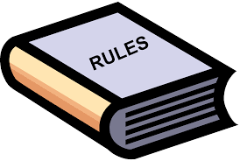

The Government made new rules because of Coronavirus.

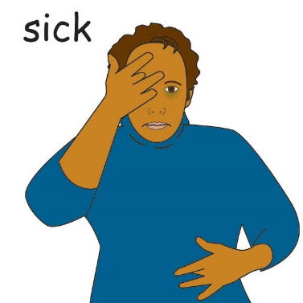

Coronavirus makes people sick.

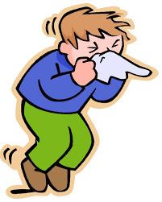

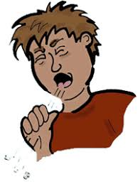Coronavirus can spread easily:

* when someone who has Coronavirus coughs or sneezes
* by touching something with the virus on it.

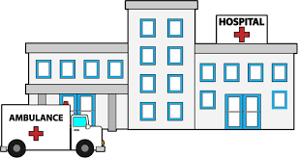

A lot of people were getting sick.

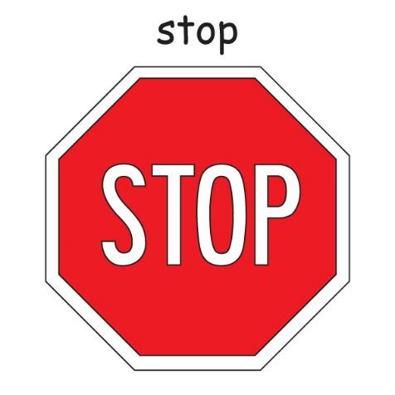



The Government said we had to stop doing a lot of things.

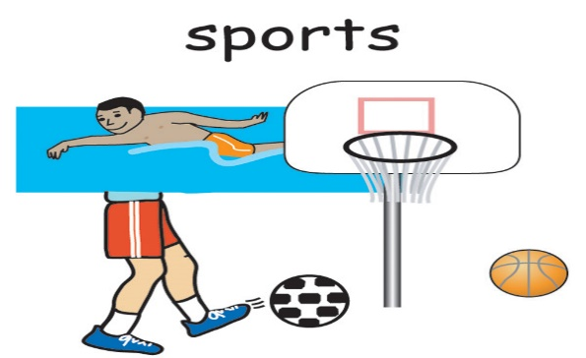

Like playing sport.

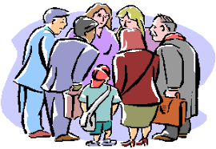

And being in big groups of people.

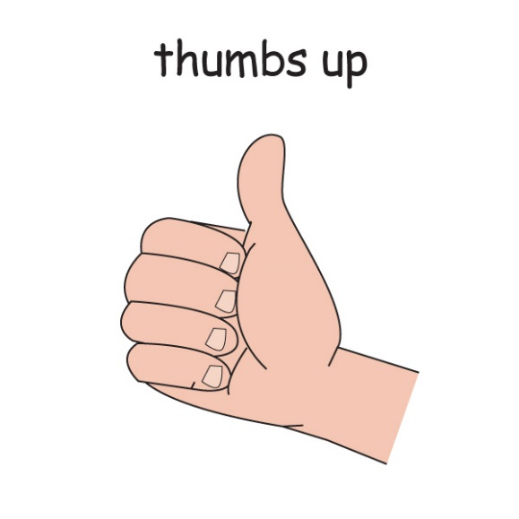

Good news.

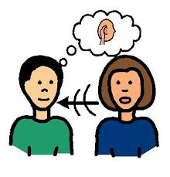



People have listened to the government rules.



Less people are getting sick from Coronavirus.



The Government has new rules that let us do some of the things we did before Coronavirus.

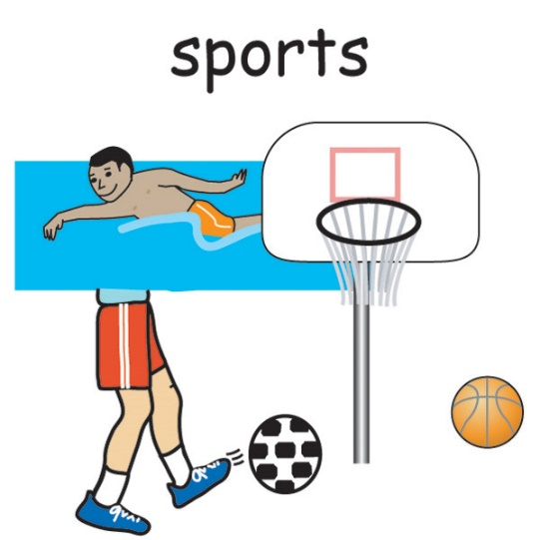



We **can** go to sport training again.

We **can** play some sport competitions again.

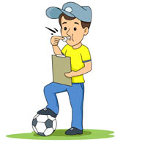Ask your coach when your competition starts.

Icon for various uses
Easy resize. All objects is layered.
Vector EPS file and image jpeg full HD.



There are things we have to do to stay safe.



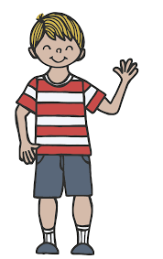

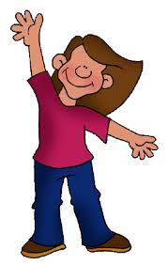

We stay 1.5 Meters away.

1.5 meters

This is 2 big steps away from another person.

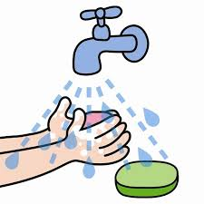

We wash our hands

* before sport
* after sport

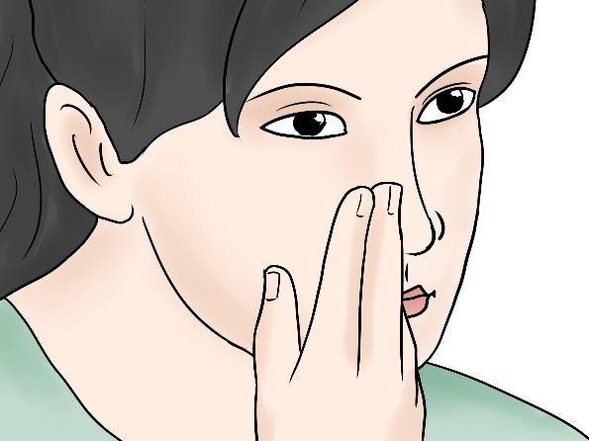

We do **not** touch our face

1.5 meters

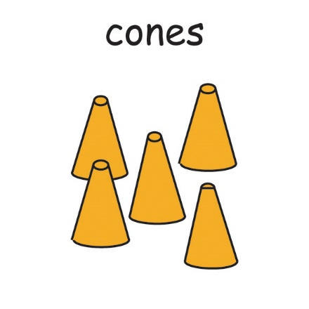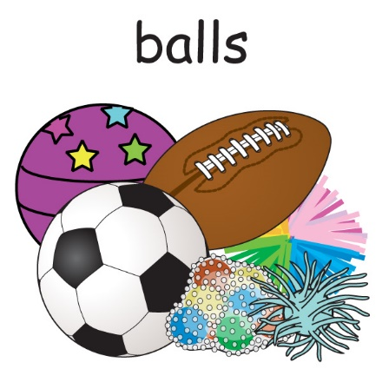

We clean sport equipment:

* balls
* cones.

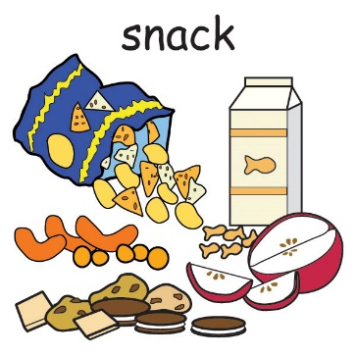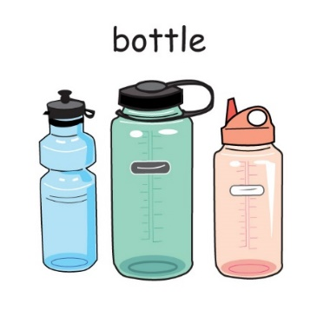

We do **not** share some things.

* do **not** share drink bottles.
* do **not** share towels.
* do **not** share food.

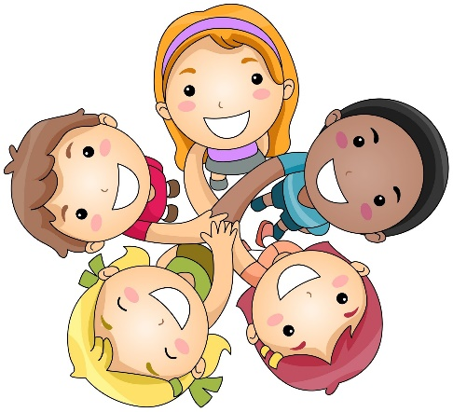

We can **not** do team huddles at training.



When the coach is talking to the team we stay 1.5 meters away.

1.5 meters

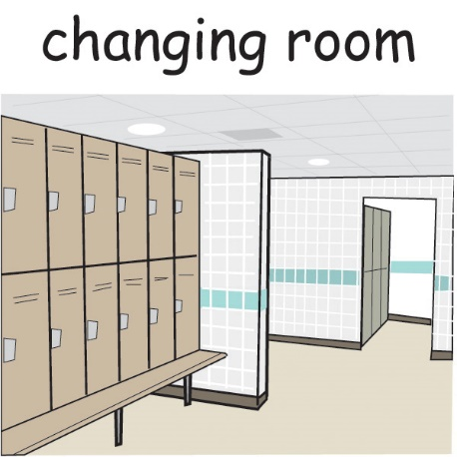

We **can** use changing rooms.

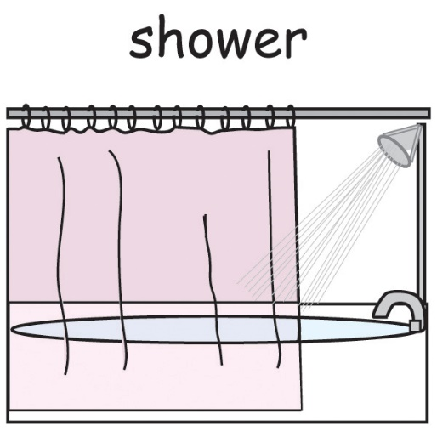

We can **not** use changing room showers

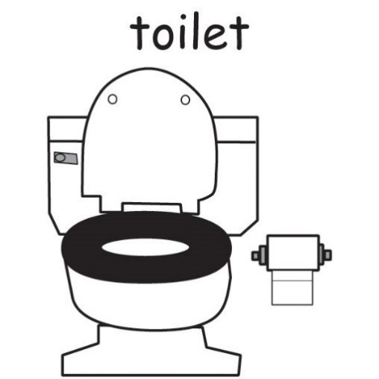



We **can** use toilets.



Remember to wash your hands after.

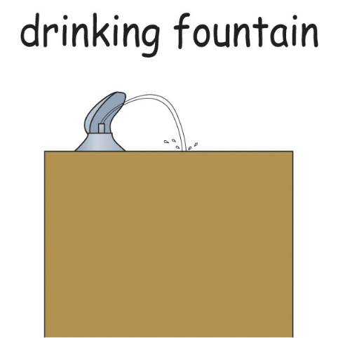

We can **not** use the drink fountains



We make sure we fill our drink bottles up at home.

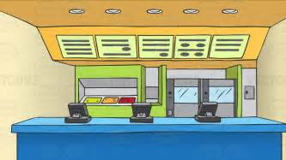

We **can** go to the canteen.

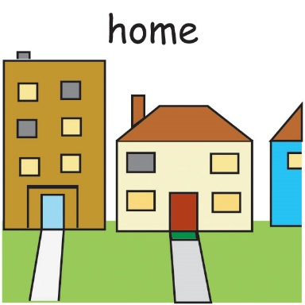

We stay home when we feel unwell.

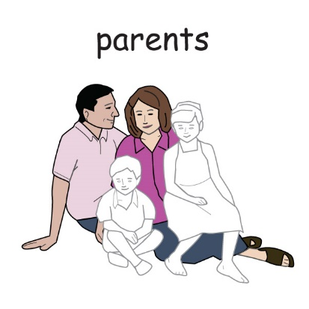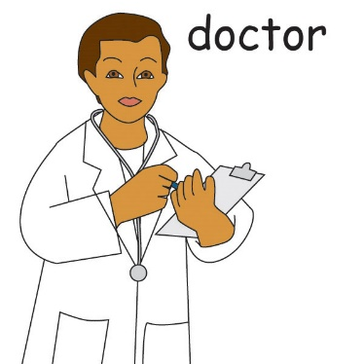

When we feel unwell we tell someone.

We can tell

* a doctor
* a parent
* a carer.



We listen to coaches about coronavirus rules.





We follow new coronavirus rules at venues.

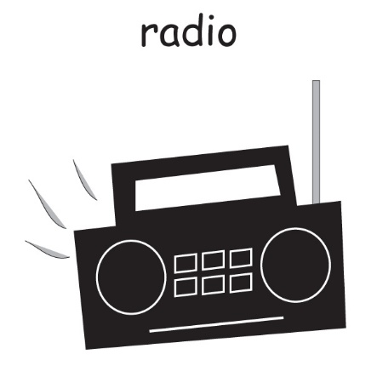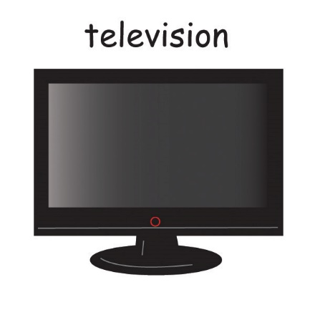

These rules might be:

* on the radio
* on television
* 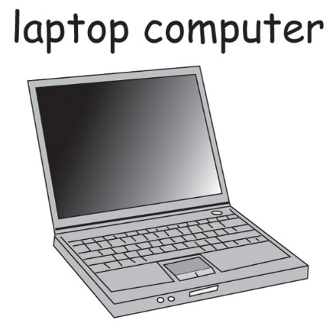on the computer



The rules help keep us safe and healthy.





If we do not understand we can ask:

* a coach
* a club member
* a caregiver

An Inclusive Sport SA & Office for Recreation, Sport & Racing Resource



[www.inclusivesportsa.com.au](http://www.inclusivesportsa.com.au/)