# Return to Recreation & Play

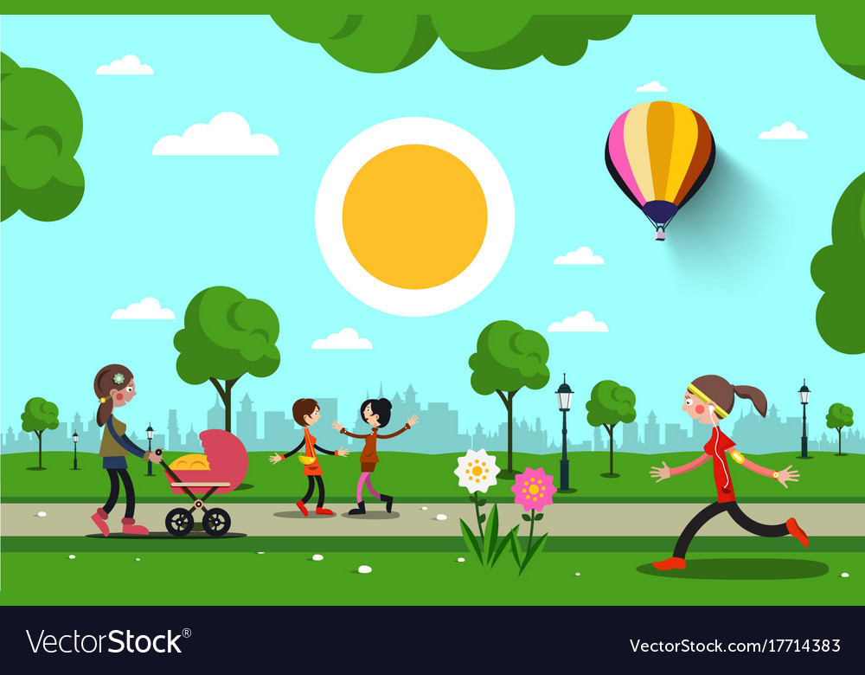

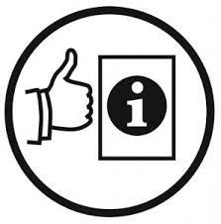Easy English Guide



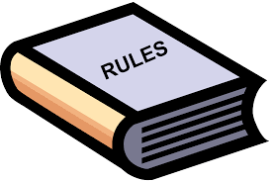

The Government made new rules because of Coronavirus.

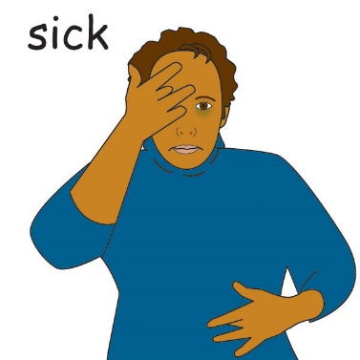

Coronavirus makes people sick.

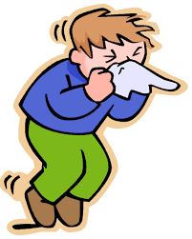

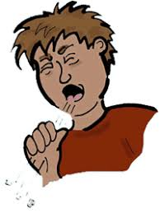Coronavirus can spread easily:

* when someone who has Coronavirus coughs or sneezes
* by touching something with the virus on it.

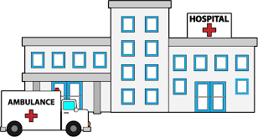

A lot of people were getting sick.

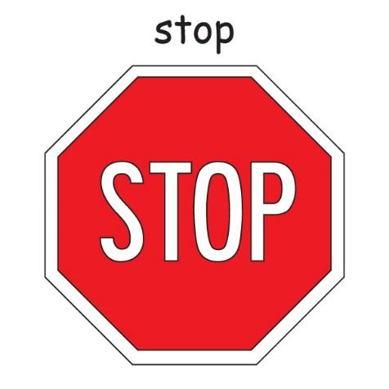



The Government said we had to stop doing a lot of things.

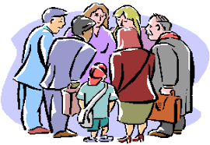

We had to stop being in big groups of people.

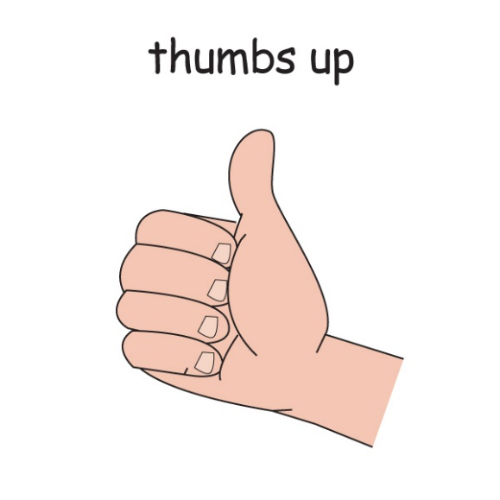

Good news.

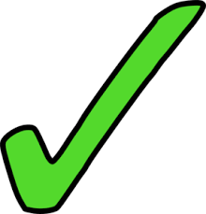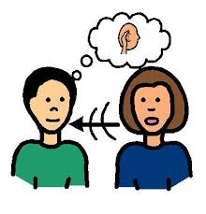



People have listened to the government rules.



Less people are getting sick from Coronavirus.



The Government has new rules that let us do some of the things we did before Coronavirus.

.

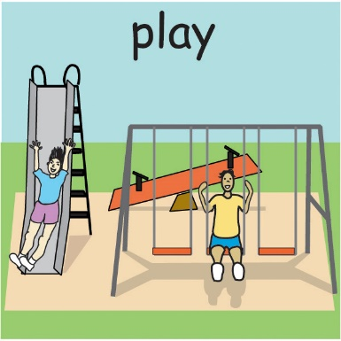



We **can** do recreation activities again.

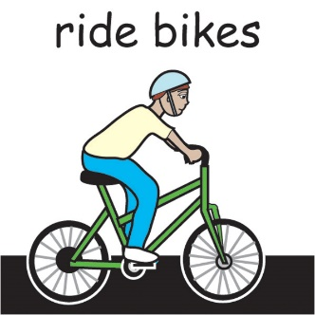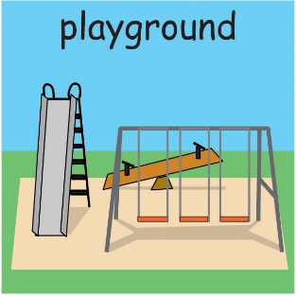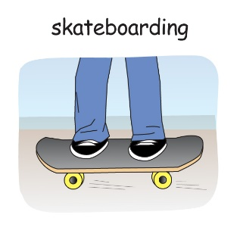

Recreation is fun things we do.

Recreation is:

* 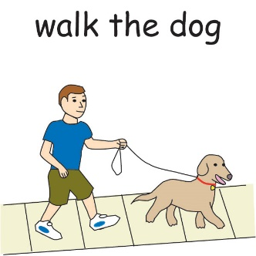going to the playground
* skateboarding
* walking the dog
* riding bikes

Icon for various uses
Easy resize. All objects is layered.
Vector EPS file and image jpeg full HD.

There are things we must do to stay safe.

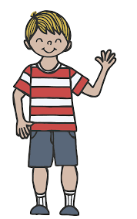

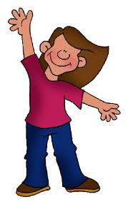

We stay 1.5 Meters away.

1.5 meters

This is 2 big steps away from another person.

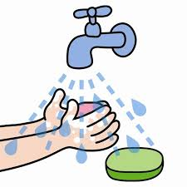

We wash our hands

* before recreation
* after recreation

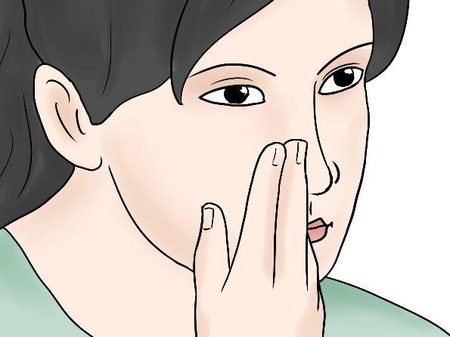

Do **not** touch your face

1.5 meters

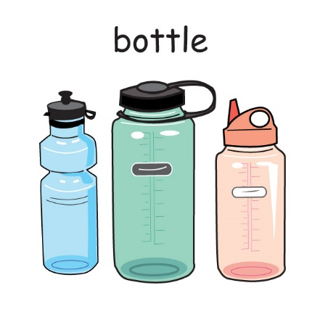

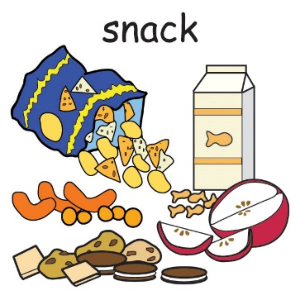

We can **not** share some things.

* do **not** share drink bottles.
* do **not** share food.

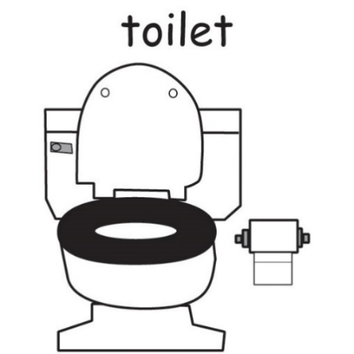

We **can** use toilets.



Remember to wash your hands after.

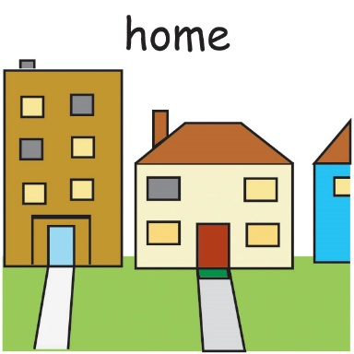

We stay home when we feel unwell.

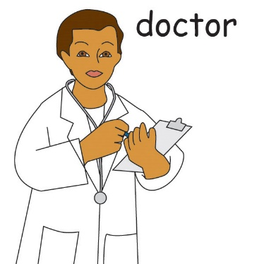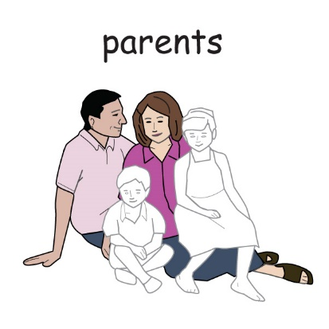When we feel unwell we must tell someone.

We can tell

* a doctor
* a parent
* a carer.





We follow new coronavirus rules.

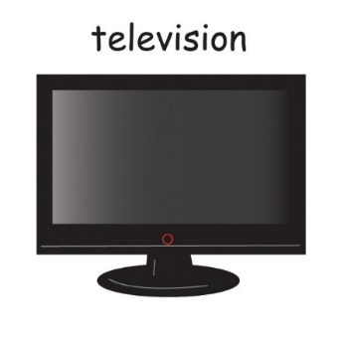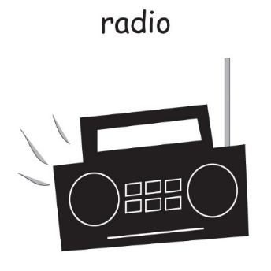

The rules might be on:

* signs at places we go to
* 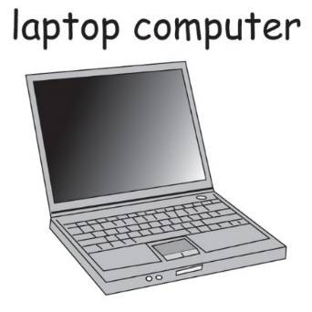on the radio
* on television
* on the computer



The rules help keep us safe and healthy.

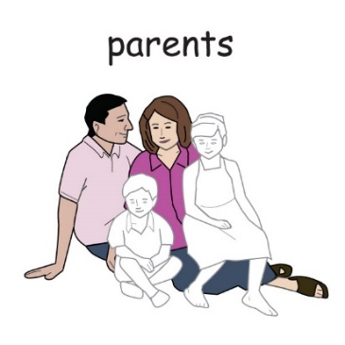

If we do **not** understand a rule we can ask:

* a parent
* a caregiver
* a friend

An Inclusive Sport SA & Office for Recreation, Sport & Racing Resource

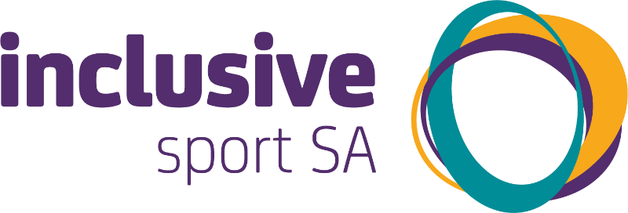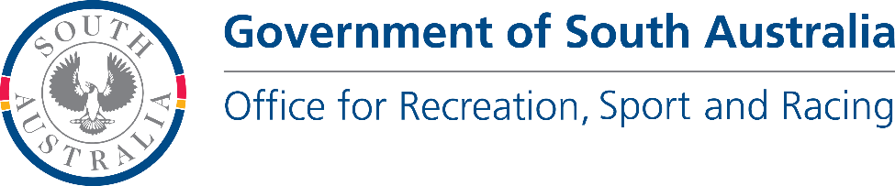

[www.inclusivesportsa.com.au](http://www.inclusivesportsa.com.au/)